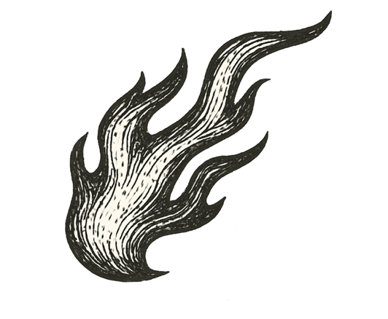
Smoke twisted across the street like a living thing. Flames flickered on both sides of the road, devouring storefronts and sending black clouds into the night sky.
My little Corolla crawled forward, low on gas, tank needle sinking as I searched for a working station. Earlier, I had spotted one — lights off but doors open. Shapes moved inside, slipping out with armfuls of goods. Not customers. Looters.
Now, the air grew darker, the road ahead a wall of swirling smoke lit by pulsing orange. Fire crackled somewhere beyond sight.
I weighed my options. Turn around? Nowhere safe behind me. Stop? Trapped. The sooner I crossed, the better — but every second felt like it could ignite.
I gripped the wheel, eased the car forward, inching into the smoke, vision shrinking to a dull, ghostly tunnel.
The riot swallowed me whole.

What monster grows when rage sets the city alight?

